University of the People

CS4404 Advanced Networking and data security

Unit 4 Written Assignment 4

Anonymous Student

You are a network engineer who has been assigned a new client company. Your senior network engineer has informed you that you will be tasked with analyzing the HTTP and TCP traffic flow in the client's network. This information will be used to improve the performance, security, and general management of the client's network.

**Introduction**

My IP Address.



Ip4 Address



Route gateway

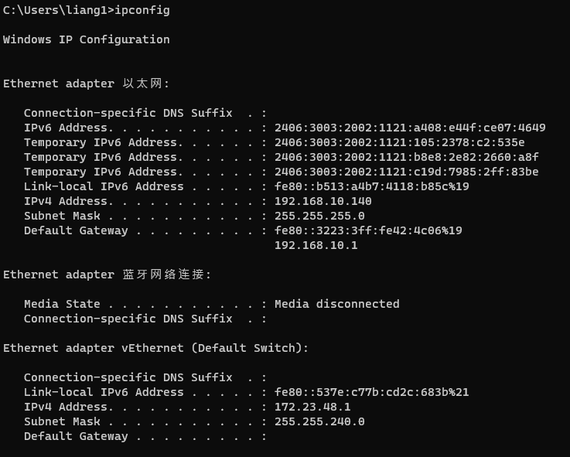

Ping example.com

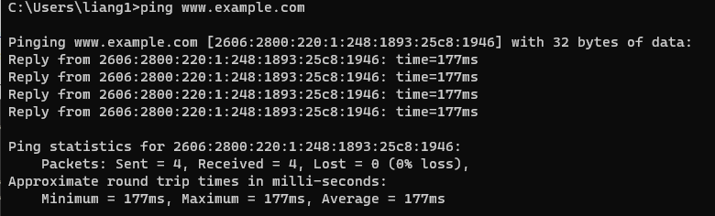

My Https request

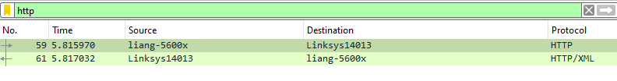

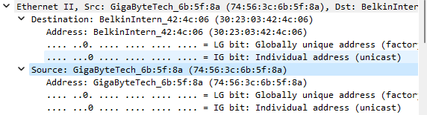

My MAC address Vendor

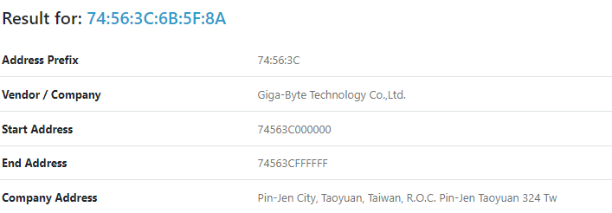

My router Mac address

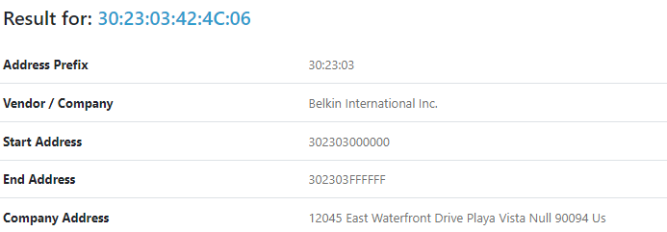

IP4 Protocal

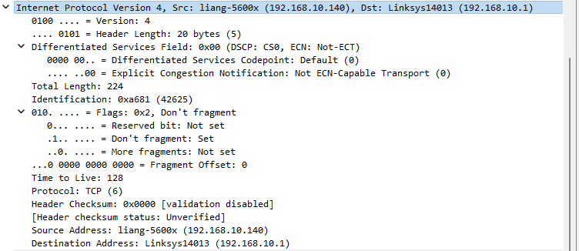

My IP version 4 is captured.

TCP protocol

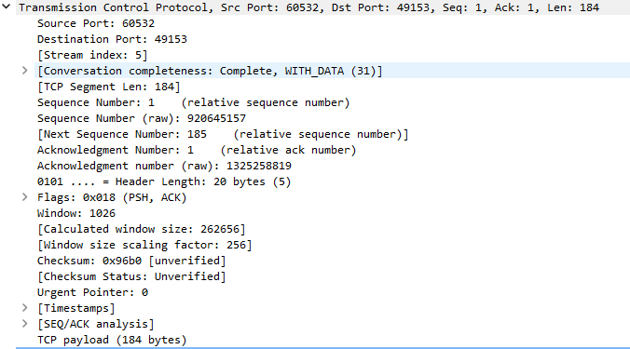

Http protocol

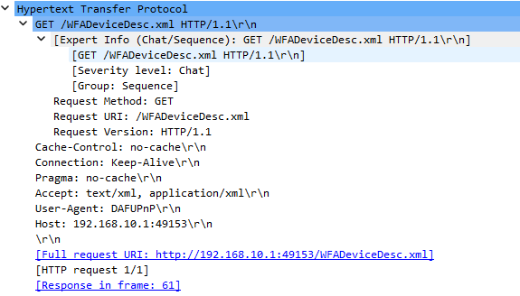

Http version is 1.1

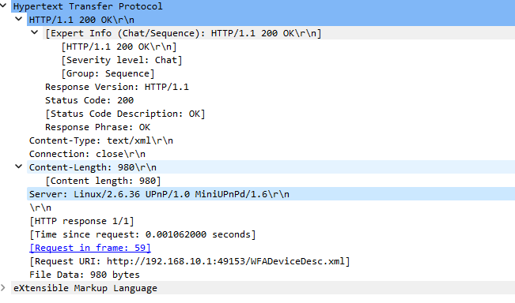

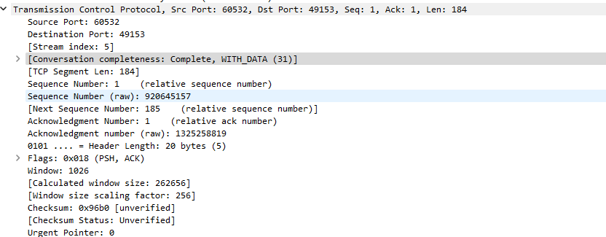

My OS system is windows

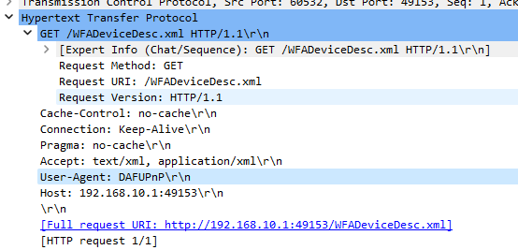

Accept language is text/html.

User agent DAFUPnP

**Ipv6 address**

TCP 3-way handshake

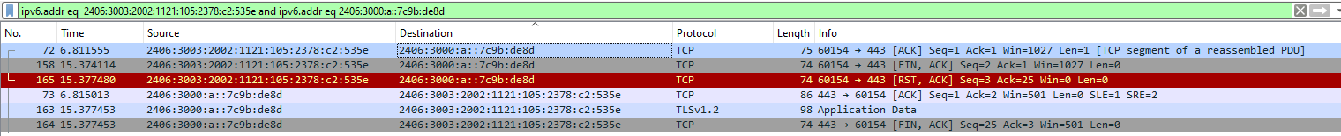

(*Wireshark User’s Guide*, n.d.)

**Conclusion**

Overall, through this practical, I have learned how to navigate the captured packets and the requests. I am able to lookup for Mac address and ip address for the packets I send and receive.

**Reference**

*Wireshark User’s Guide*. (n.d.). Retrieved November 19, 2023, from https://www.wireshark.org/docs/wsug_html_chunked/index.html